Appendix B.1 — Final Electrical Schematic (Power Distribution, Safety, Motor and Distance Sensor Sub-system)
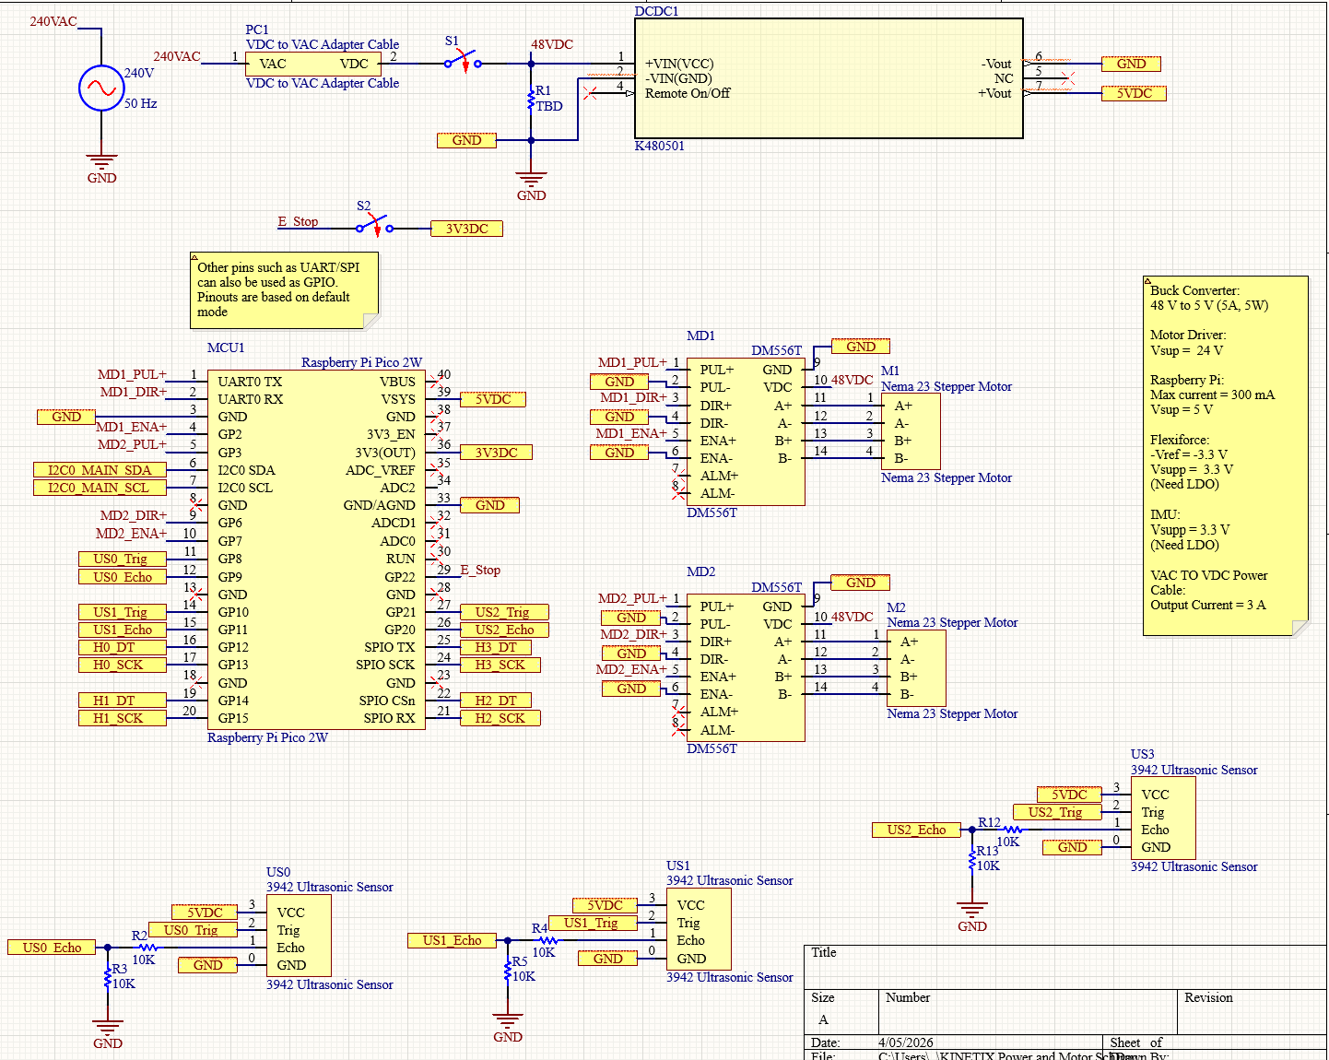

Appendix B.2 — Final Electrical Schematic (IMU Sensor Sub-system)
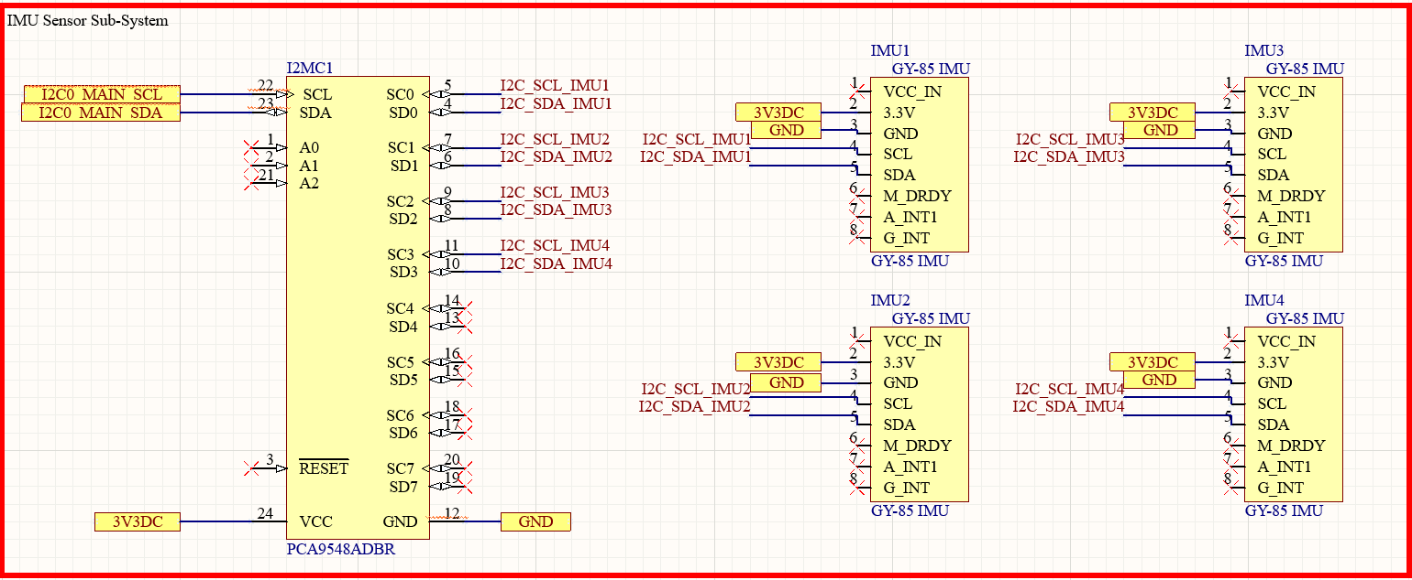

Appendix B.3 — Final Electrical Schematic (Load Cells Force Sensor Sub-system)
